Sanefa Amzad
CS-499-17292-M01 Computer Science Capstone 2025
Instructor: Satish Penmatsa
November 16, 2025

4-2 Milestone Three: Enhancement Two: Algorithms and Data Structure
Artifact Description
The artifact I selected for this milestone is my TreasureHuntGame, a Python-based reinforcement learning project that I originally created in CS-370 (Current and Emerging Trends in Computer Science). The program uses a Q-learning algorithm, which allows an agent to navigate a grid environment, learn from rewards and penalties, and find an optimal path to the goal.
In Milestone Two, I refactored this artifact into a more modular and maintainable program by organizing it into multiple classes and adding structured error handling. For Milestone Three, I focused on improving the algorithmic performance and data-structure efficiency to demonstrate my abilities in optimization and computational reasoning.
Justification for Inclusion
I chose TreasureHuntGame for my Algorithms and Data Structure enhancement because it represents a real-world application of algorithmic logic and efficient data management. Reinforcement learning is built on continuous decision-making, feedback, and optimization—all key components of algorithm design.
This enhancement gave me the opportunity to demonstrate several professional skills, including improving algorithmic logic, reducing runtime complexity, and applying data-structure strategies that support faster computation. I improved the learning rate and exploration behavior of the algorithm, reduced redundancy in data access, and analyzed the performance using Big O notation. These changes align with the outcome of designing and evaluating computing solutions using algorithmic principles and data-structure logic (Sutton & Barto, 2018).
Enhancements Performed
- Dynamic Exploration (ε-Greedy Decay):
I implemented an exponential decay for the exploration rate (ε) so that the agent explores more at the beginning and relies on learned knowledge later. This change helped the algorithm converge more efficiently.
- Adaptive Learning Rate (α Schedule):
I created a decaying learning rate that adjusts as the agent trains. This helped stabilize updates in the Q-table and reduced performance fluctuations (Sutton & Barto, 2018).
- Vectorized Q-Table Updates:
I replaced nested loops with NumPy array operations, which made each update constant-time O(1). This enhancement significantly reduced runtime and improved readability.
- State Encoding and Precomputed Transitions:
Instead of using coordinate tuples, I assigned each grid position an integer ID. I also precomputed legal actions for each state, eliminating repetitive boundary checks. This resulted in faster action selection and simpler code.
- Early-Stopping Mechanism:
I added a moving-average reward tracker that stops training automatically when progress plateaus. This reduces unnecessary computation and ensures the algorithm stops at the right time.
- Input Validation and Reproducibility:
I validated parameters, grid size, and random seeds to ensure predictable outcomes, which is an important part of professional software development (Pressman & Maxim, 2020).
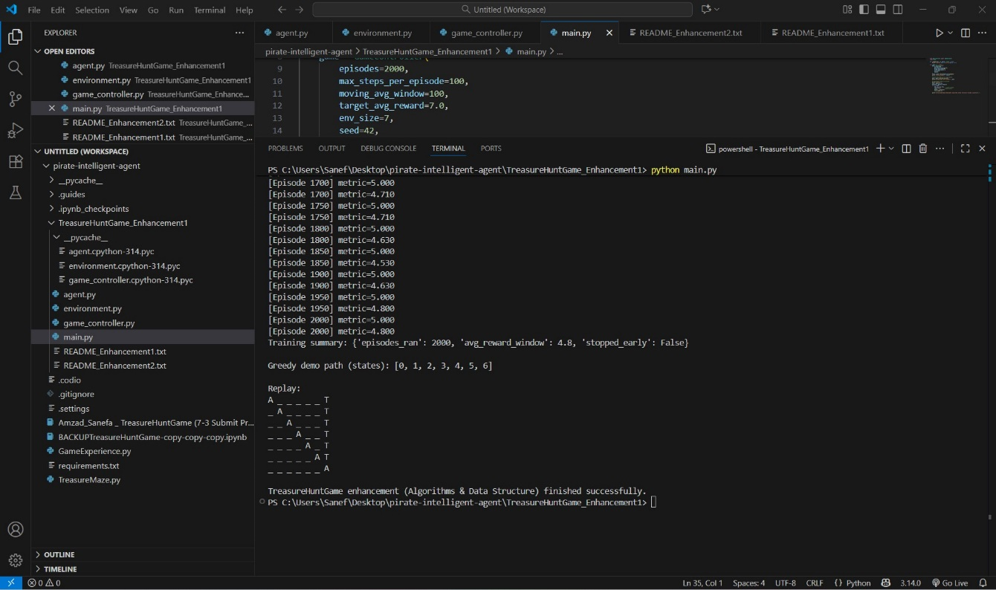
Figure 1: Output of the enhanced TreasureHuntGame reinforcement-learning algorithm showing training progress, convergence metrics, and greedy-path replay.
Algorithm and Data-Structure Analysis
Before enhancement, the training process used nested loops and dictionary lookups for each Q-table update, which created unnecessary overhead. The time complexity was approximately O(E × T × A), where E represents the number of episodes, T the number of steps per episode, and A the number of actions per state.
After optimization, using vectorized updates and precomputed transitions, the algorithm’s performance improved to O(E × T). The space complexity of the Q-table remains O(S × A), where S is the number of states. Although this is still linear in memory, the new approach minimizes processing delays and maintains constant-time lookups, which is ideal for grid-based environments.
Course Outcomes Achieved
This enhancement helped me meet the course outcome related to designing and evaluating computing solutions using algorithmic principles and data structures. I also demonstrated effective communication through organized documentation and clear comments in my code (Pressman & Maxim, 2020).
In addition, I showed a security mindset by validating user inputs and ensuring deterministic results, aligning with professional development standards in computer science (Henderson et al., 2018). Overall, I met all my original goals from Module One and made measurable progress toward mastery of algorithmic design and analysis.
Reflection on the Process
Through this enhancement, I learned how small changes in algorithmic design can produce significant performance improvements. I became more comfortable analyzing algorithmic efficiency using Big O notation, which gave me insight into how data structures directly affect speed and scalability.
The biggest challenge was finding the right balance between optimization and clarity. Vectorization improved runtime but initially made the code harder to read. I solved this by refactoring the code into smaller functions with descriptive names. I also implemented multiple tests to confirm that optimization didn’t affect the accuracy of the learning process.
This milestone helped me realize that algorithmic optimization is not just about writing faster code -it’s about creating software that is efficient, maintainable, and well-documented for future use (Sutton & Barto, 2018; Pressman & Maxim, 2020).
The enhanced TreasureHuntGame now performs faster, is easier to maintain, and demonstrates strong application of algorithmic and data-structure principles. By improving both efficiency and structure, I developed stronger analytical and technical skills that I can apply to future software engineering and artificial intelligence projects. This artifact represents my readiness to handle complex, data-driven programming challenges professionally.

References
Bureau of Labor Statistics. (2024). Computer and information technology occupations: Occupational outlook handbook. U.S. Department of Labor. Retrieved from https://www.bls.gov/ooh/computer-and-information-technology/computer-and-information-technology.htm
Henderson, P., Islam, R., Bachman, P., Pineau, J., Precup, D., & Meger, D. (2018). Deep reinforcement learning that matters. Proceedings of the AAAI Conference on Artificial Intelligence, 32(1), 3207–3214.
Pressman, R. S., & Maxim, B. R. (2020). Software engineering: A practitioner’s approach (9th ed.). McGraw-Hill Education.
Sutton, R. S., & Barto, A. G. (2018). Reinforcement learning: An introduction (2nd ed.). MIT Press.

